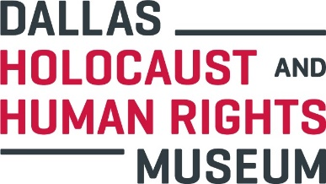
Museum Experience Lead

Department: Advancement
Reports To: Museum Experience Manager
FLSA Status: Full-Time/Non-Exempt, weekend hours are required

Summary
The Museum Experience Lead is responsible for ensuring that the Museum visitors have the highest quality experience.

Job Duties

- Be the “face of the Museum” by providing excellent customer service at all times
- Foster an environment of teamwork and commitment to the Museum’s mission
- Welcome, orient, and organize school groups upon their arrival for scheduled tours
- Welcome, orient, and organize walk-in visitors upon their arrival
- Ensure the Museum exhibit and theaters are functional each morning
- Receive and process payments via PatronManager (POS System)
- Produce weekly attendance reports
- Open, close and balance the cash registers on a daily basis. Complete all required daily reports for tracking daily operating transactions. Comply with all of the Museum’s cash handling, financial accounting and financial reporting policies and procedures
- Promote Museum membership and assist with visitor enrollment
- Assist with survivor relations by ensuring that survivors are well taken care of during their time in the Museum
- Work programs and fundraising events, on and off-site as needed
- Answer phone, screen and forward calls, take phone messages, and provide general information regarding the Museum, directions, exhibitions/events and programs
- Required to work on the weekends
- Perform other duties, tasks, projects, and responsibilities as needed

Key Requirements

- Bachelor’s Degree preferred
- Minimum 2 years of recent cash handling and customer service experience in retail environment
- Supervisory experience preferred
- Strong people management skills
- Proficiency with Microsoft Excel, Outlook and Word
- Ability to work with minimal direct supervision
- Ability to professionally interact with all levels of museum staff and external constituents
- Ability to communicate in English, fluency in Spanish desirable
- Ability to stand and walk and climb stairs for extended periods of time
- Ability to work flexible schedule as required including nights and weekends
- Excellent interpersonal skills with individuals of all ages, backgrounds, ethnicity and gender orientation
- Ability to perform detail-oriented work
- Strong written and verbal communication skills

Physical Requirements
- Standing and walking are required
- Lifting up to 40 pounds

Competencies
- Judgment/Decision Making
- Communication – Oral and Written
- Organization/Planning
- Business Literacy
- Customer Service
- Integrity
- Initiative
- Teamwork

The Dallas Holocaust and Human Rights Museum is an equal opportunity employer, we value and strongly encourage a diverse environment.

Applicants, please send cover letter referencing the job title and resume to resume@dhhrm.org

